**Question 2 b:**

Output of the models accuracy scores with green highlight as the highest accuracy score:

{(3, 'gini'): 0.710204081632653,

(3, 'entropy'): 0.6326530612244898,

(5, 'gini'): 0.710204081632653,

(5, 'entropy'): 0.7122448979591837,

(10, 'gini'): 0.7326530612244898,

(10, 'entropy'): 0.7306122448979592,

(15, 'gini'): 0.736734693877551,

(15, 'entropy'): 0.736734693877551,

(20, 'gini'): 0.7551020408163265,

(20, 'entropy'): 0.7448979591836735 }

**Question 2c:**

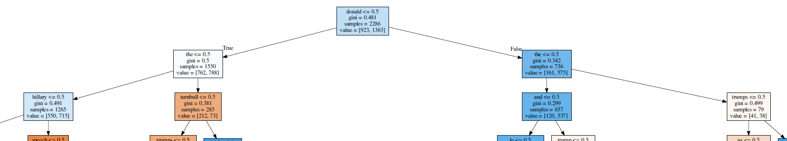First two layers of the decision tree with parameters max_depth=20, and criterion = ‘gini’